Albuquerque Isotopes Joint Scientific Statement on Nuclear Energy

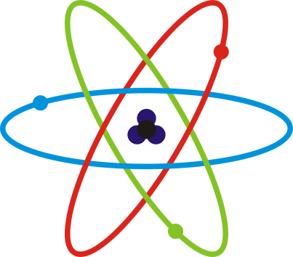

By: Sarah Anthony, Travis Carlson, Zach Flora, Ranier Ford, Tessa Hermesmen, Allie Rodd, and Will Smock-Egan

Compiled by Will Smock-Egan

Table of Contents:
How Nuclear Fission Works - Travis Carlson Page 3

The Meaning of E=MC² and its Relevance to
Nuclear Fission - Zach Flora Page 4

The Mining, Milling and Enrichment of Radioactive
Materials - Zach Flora Page 5

The Full Design of a Light Water Power Plant - Sarah Anthony Page 9

The Operating Processes of Light Water Nuclear
Power Plants - Ranier Ford Page 10

Safety Risks Accompanying the Use of
Nuclear Power - Tessa Hermesman Page 12

The Science of Global Climate Change and its Relation to
Nuclear and Fossil Fuels Power Plants - Tessa Hermesmen Page 13

Nuclear Waste: Sarah Anthony Page 18

The Environmental and Safety Considerations for the
Storage of Nuclear Waste - Ranier Ford Page 18

Emissions from Nuclear Power Plants – Allie Rodd Page 20

The Best Financial Estimates of the Cost of
Nuclear Power Generated Electricity – Allie Rodd Page 20

The Greenhouse Effect and Its Relation to
Global Climate Change – Travis Carlson Page 22

Greenhouse Gases and Their Structure – Travis Carlson Page 22

The Change in The Amount of Greenhouse Gas in
The Atmosphere Over Time – Will Smock-Egan Page 23

Predictions of Global Climate Change – Will Smock-Egan Page 22

Emissions from Nuclear Power Plants Compared to Coal and
Natural Gas Plants – Will Smock-Egan Page 24

Combustion of Fossil Fuels Related to
Global Climate Change – Will Smock-Egan Page 25

Levelized Costs of Electric per kWh (Kilowatt Hour) – Will Smock-Egan Page 26

Color Format:
Travis Carlson

Sarah Anthony

Allie Rodd

Ranier Ford

Tessa Hermesman

Zach Flora

Will Smock-Egan

How nuclear Fission Works
Energy is stored in the nuclei of atoms. Fission is when those nuclei are split and release lots of energy. It happens as such:
1. A neutron strikes the nucleus of a heavy and potentially unstable isotope.
2. The nucleus becomes unstable.
3. The nucleus vibrates and splits. The split occurring is fission.
Since a fast neutron can’t be captured, neutrons are slowed down through moderation in order to increase their capture probability in fission reactors. A single fission event can yield over 200 million times the energy of the neutron which triggered it! Fission produces two or three neutrons, two new, lighter weight atoms called fission products, and energy (mostly as heat). The energy that is released is that which was holding the hadrons (neutrons and protons) together. Chain reactions are when fission occurs, and the neutrons released from that hit more atoms, releasing more neutrons, which hit more atoms. The results in lots of energy! For example, in U-235, a slow neutron is captured by the atom’s nucleus, turning it into U-236 and making it unstable. The nucleus splits, producing Kr-92 and Ba-141 and sending more neutrons off that can start a chain reaction. This can be seen in the visual below. 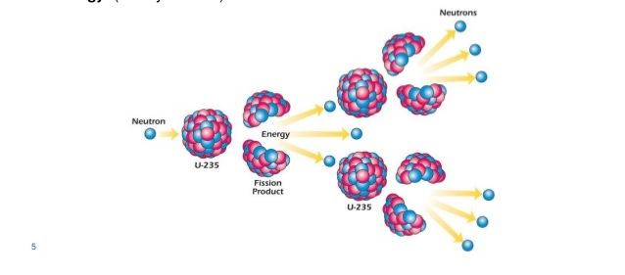
"The Harnessed Atom - Lesson 5 - Fission and Chain Reactions." The Harnessed Atom. ORAU, 04 Oct. 2013. Web. 29 Apr. 2014.
Schirber, Michael. "What Is Nuclear Fission?" LiveScience. TechMedia Network, 12 Mar. 2010. Web. 29 Apr. 2014.
Nave, R. "Uranium-235 Fission." Uranium-235 Chain Reaction. GSU, n.d. Web. 29 Apr. 2014.
Nave, R. "Nuclear Fission." Nuclear Fission. GSU, n.d. Web. 28 Apr. 2014.

The Meaning of E=MC² and its Relevance to Nuclear Fission

E=MC2 is a famous equation discovered by physicist Albert Einstein. In E=MC2, E is energy in terms of Joules, m is mass in kg, c is the speed of light in vacuum (3*10^8 m/s). He derived the problem from Maxwell's electromagnetic theory. Maxwell stated that light carries a momentum, which is to say that a wave carries an amount of energy (“E = Mc2: The Unforgettable”). The conservation of energy principle states that the total energy of an isolated system is conserved and energy can only change form and cannot be created or destroyed. Overall E=MC2 is a way to look at how much energy a mass moving at the speed of light will create. In contrast the equation of kinetic energy determines how fast a mass will move when a certain amount of energy (or force) is applied. This can be seen through nuclear fission. Nuclear fission being a process where a nucleus splits into two smaller nuclei (“nuclear fission”). Nuclear fission mainly used in nuclear power plants because this splitting of nuclei produces large amounts of energy for a small amount of mass. If an entire 2 kilograms of uranium was converted to pure energy all at once it would be equal to about 30 million barrels of oil. This represents the nuclear potential energy if it could be all converted at once which is impractical.
      - E= 2(3*10^8)^2
      - E= 1.8^17
      - E= 180,000,000,000,000,000 J created by uranium
      - 180,000,000,000,000,000 J in uranium/5861520000 J in oil
      - 30708758.14 barrels of oil

Bibliography
"E = Mc2: The Unforgettable Equation of Einstein's Miracle Year (Picture Essay of the Day)." Encyclopedia Britannica Online. Encyclopedia
Britannica, n.d. Web. 29 Apr. 2014.
"Mass–energy Equivalence." Info. N.p., n.d. Web. 30 Apr. 2014.
<en.wikipedia.org/wiki/Mass–energy_equivalence>.
"Nuclear Fission." Wikipedia. Wikimedia Foundation, 28 Apr. 2014. Web. 29 Apr. 2014. <http://en.wikipedia.org/wiki/Nuclear_fission>.

The Mining, Milling and Enrichment of Radioactive Materials

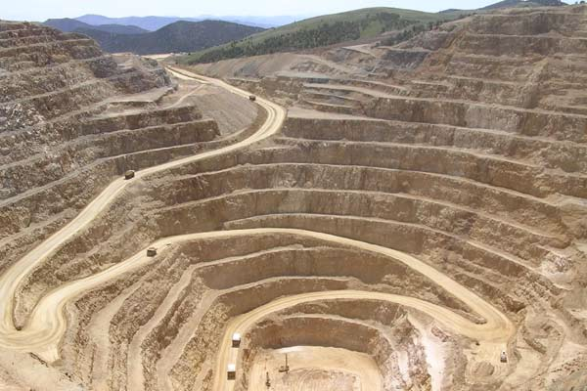
Mining, milling, and enriching radioactive materials is a long and complicated process. Uranium is the most popular source so it will be used through this paper. Uranium is mined in many states in the U.S including Colorado, Florida, New Mexico and many more states. Right now the U.S has approximately 207,400 tonnes of uranium which is only about 4% of the world’s supply. Overall the world has about 5,327,200 tonnes with Australia having rights to 31% of it (“Supply of Uranium”). In order to use these radioactive materials they have to be mined, milled, and enriched. When mining for radioactive materials there are 3 main ways to extract the ore.
Open pit mining involves a hole that can be up to 400 feet deep and football fields wide. This hole is created to expose the uranium ore in the ground and is collected by bulldozers and other equipment by stripping the radioactive ore out of the ground. The problems with open pit mining is the environment around the pit can be polluted with radioactive shavings, dust, and human impact from workers. There are regulations that require the company to help preserve and clean up the area around the pit. A good part about open pit mining is workers have low exposure to radiation and harmful gases ("Uranium — How Is It Mined?”).

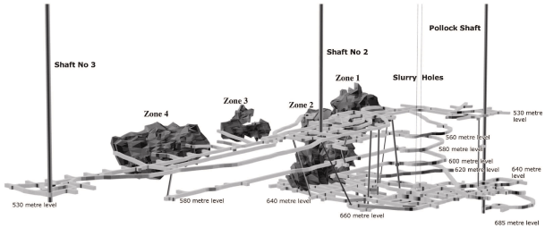
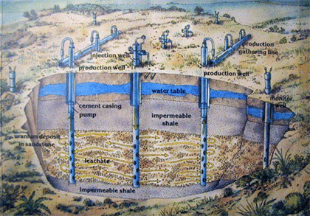
The second way of mining, is underground mining. Underground mining has to be conducted when the uranium is too far underground for open pit mining. A underground mining facility is composed of shafts and tunnels far underground. mining companies figure out where the radioactive ore is and put a shaft in that vicinity and then start mining tunnels in different horizontal directions. From there miners attach a drill head to a metal pull from a tunnel higher up and pulls the drill through the radioactive materials. ("Uranium Mining.”) Overall underground mining is just like hard rock mining. With underground mining there is the least amount of pollution to the environment behind it, yet the miners are most exposed to radio active gasses like radon gas (“Uranium — How Is It Mined?”).

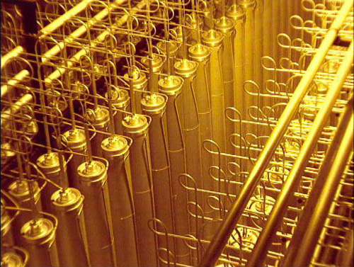
The third way is In Situ Recovery or in short ISR mining. ISR mining starts out with multiple wells drilled deep into the earth where the uranium is. The wells that are used during this process are called injection wells and production wells. Injection wells uses on-site ground water that is fortified with gaseous oxygen and pumped into the uranium ore far underground. This solution dissolves the uranium from the sandstone and is sucked back up through the production well. From there it is pumped to a recover ion exchange column. In this column the uranium solution is loaded onto millions of synthetic resin beads and is transported to a processing facility. ISR mining is the safest for both radiation contaminating the environment and for the workers mining ("Uranium 101.”).

For both open pit mining and underground mining the milling process is the same. This is because bother are not a extra fine powder from the mine and are not pure uranium so they have to be purified. They do this by transporting the uranium to a milling facility and crushing the rocks into extra fine dust and add it to water. After they do this it is moved to a precipitation tank and is precipitated with both Hydrochloric acid and hydrogen peroxide. This turns it into a substance called yellow cake slurry. From there the barren resin is filtered through a filter process which separates the uranium solids from the salt solutions using filter clothes. Then is washed with fresh water to remove the contaminates out of it. Then is finally is moved to a vacuum dryer to dehydrate and is packaged as yellow cake uranium (“Nuclear Fuel Processes”). The milling process for ISR mining is quiet similar. Instead of grinding up the rocks the solution shows up to the facility as slurry in resin beads. To separate the beads from the slurry solution they are alluded with a salt water solution. This releases the uranium and is converted back to a more concentrated slurry solution with no resin beads. From there it goes under the same process (“Uranium 101”)
Lastly the radioactive material needs to be enriched before being used for any main application like nuclear power. The yellow cake uranium is transported to a enrichment site where it is turned to a gas by reacting with hydrofluoric acid. This creates Uranium hexafluoride which has two isotopes of uranium infused with it. These isotopes are U-235 and U-238. Usually there is about 1% U-235 in the compound. In order to create reactor grade uranium there has to be about 3-5 percent U-235 present. This is because U-235 fissions easily making reactors effective ("Nuclear Fuel Processes”). In order to separate the two isotopes they put the gas into a centrifuge. A centrifuge is a gas chamber that spins at very highs speeds to separate the two uranium gases. It can do this because U-238 has a bigger mass making it heavier and making it move towards the outside of the centrifuge and keeping U-235 in the middle. Calcium is then added to the gases. Calcium reacts with florine and leaves pure uranium isotopes separate. Giving you a enriched uranium to the percentage of U-235 you want to create. ("Enriched Uranium”).

Bibliography
"Uranium Mining." Wikipedia. Wikimedia Foundation, 30 Apr. 2014. Web. 30 Apr. 2014.
<http://en.wikipedia.org/wiki/Uranium_mining>.

"Uranium 101." In Situ Recovery (ISR). N.p., n.d. Web. 30 Apr. 2014.
<http:// www.uraniumenergy.com/uranium/in_situ_leach/>.

"Uranium — How Is It Mined?" Uranium: How Is It Mined? N.p., n.d. Web. 30 Apr. 2014.
<http://geoinfo.nmt.edu/resources/uranium/mining.html>.

"Nuclear Fuel Processes." Nuclear Energy Institute. N.p., n.d. Web. 30 Apr. 2014.
<http://www.nei.org/Knowledge-Center/Nuclear-Fuel-Processes>.

"Supply of Uranium." Uranium Supplies:. N.p., n.d. Web. 29 Apr. 2014.
<http://www.world-nuclear.org/info/Nuclear-Fuel-Cycle/Uranium-Resources/Supply-of-Uranium/>.

"Enriched Uranium." Wikipedia. Wikimedia Foundation, 25 Apr. 2014. Web. 30 Apr. 2014. <http://en.wikipedia.org/wiki/Enriched_uranium>.

The Full Design of a Light Water Power Plant
A light water nuclear power plant uses light water (regular water) as the moderator and primary coolant, which cools the radioactive uranium and creates steam to turn turbines in the electric generators to produce electricity. This all happens within the nuclear power plant, inside of the containment structures and cooling towers. The containment structures have very thick walls of steel-reinforced concrete. On the other side of that wall there is the primary coolant, which prevents the entire structure from over heating. Also inside there is the secondary coolant, which teams up with the primary coolant, both are keep the containment structure and the radioactive material inside from melting through the crust of the earth. The radioactive material used in these power plants, as the source of energy is uranium and it is kept in the form of uranium rods in the reactor core of the containment structure. These uranium fuel rods are undergoing radioactive decay and are at high risk of reacting, a reaction between these highly radioactive materials would burn through the primary and secondary coolants, through the containments structure’s walls and into the earth. Think of a nuclear bomb, the same type of fission reaction is happening inside of a nuclear weapon and inside of a reactor core of a nuclear power plant. The reaction, though, in a nuclear weapon such as a bomb, occurs at a much faster rate and can be much more harmful. To keep this reaction from happening at a dangerous rate, inside of the reactor core there are control rods. The control rods are made of materials that absorb neutrons to prevent fission from occurring and they block a chain reaction from happening between the uranium rods. They can be lifted or lowered to block more or less of the reaction to produce more or less power. Outside of the reactor core there is the cooling coil, it runs through the entire containment structure and serves as the tertiary coolant working alongside the primary and secondary coolants produce steam. The nuclear fission reaction occurring within the reactor core is so hot that it evaporates the water and creates pressurized steam. This steam is then transported out of the containment structures and turns the turbines, which power the generators and goes through the transformers through electrical wires to the city to power our lives.
There are two different types of nuclear power plants, the pressurized water reactors and the boiling water reactors. These both use the same light water reactors and use water as their primary coolant. A pressurized water reactor has a primary coolant circuit that runs water under large amounts of pressure through the reactor core. The secondary coolant in a pressurized water reactor is in the form of steam, which is used as power to turn the turbines. The boiling water reactors work similarly but have only one circuit, which water runs through at a much lower pressure. The lower pressure allows the water to boil inside of the reactor core at around 285˚C. Nearly 15% of the water is stored at the top of the core in the form of steam. This steam passes through steam separators and then to the turbines. From there it goes through the generator, then through the transformer and through electrical wires to the city or town.
Boiling Water Reactor
Pressurized Water Reactor
"Light Water Reactor." Light Water Reactor. N.p., n.d. Web. 30 Apr. 2014.
"Nuclear Power Reactors." Nuclear Reactors. N.p., n.d. Web. 27 Apr. 2014.
"Containment Structure." NRC: Glossary --. N.p., n.d. Web. 30 Apr. 2014.
"Pressurised Water Reactor VS Boiling Water Reactor | Nuclear Energy | CLP Group." Pressurised Water Reactor VS Boiling Water Reactor | Nuclear Energy | CLP Group. N.p., n.d. Web. 30 Apr. 2014.

The Operating Processes of Light Water Nuclear Power Plants
What is the fuel for light water nuclear reactors and what form does this fuel take?
The basic fuel used in a light water reactor is uranium and plutonium. Uranium occurs naturally and is 500 times more abundant than gold, and it is also found in concentrations of about four parts per million in granite which makes up 60% of the Earth’s crust. However, only 0.7% of natural uranium is fissile (or useful in nuclear power generation) (World, Fuel). Uranium-235 is a fissile isotope and isolation of it requires a physical process (known as enrichment) of concentrating one isotope relative to the others. To complete the process of enrichment, the uranium has to be in a gaseous form. Often, uranium dioxide can be used as a fuel type for reactors that do not require enriched uranium. Alternatively, uranium hexafluoride is used if the reactor requires enriched uranium. The gaseous uranium hexafluoride will be separated into two streams, one to be enriched to the required level and the other to be depleted into U-235 (World, Power).
The fuel used in the reactors generally takes the form of ceramic-like pellets. They are formed from pressed uranium oxide which was encased in a metal tube to form a fuel rod. Depending on the varying need of consistency in the characterizations of the fuel, the dimensions of the pellets and other components will change (World, Fuel).

"The Nuclear Fuel Cycle." Representing the People and Organizations of the Global Nuclear Profession. World Nuclear Association, Dec. 2012. Web.

"Nuclear Power Reactors." Nuclear Reactors. World Nuclear Association, n.d. Web. 24 Apr. 2014.

How much energy does a typical power plant produce? How many homes can this serve?
On average, a nuclear power plant in the U.S. will generate approximately 11.8 billion kilowatt-hours. With 65 nuclear plants containing 104 operating reactors that generated a total of 769 billion kilowatt-hour, the nuclear power is making up 19% of the nation’s electricity. A typical household in the U.S. consumes around 11,200 kWh per year and a typical power plant can power up to 893,000 homes. This means that for as long as the nuclear power stays a sustainable resource, we should be able to power 58,045 million homes in a year (EIA, Energy).

"U.S. Energy Information Administration - EIA - Independent Statistics and Analysis." How Much Electricity Does a Typical Nuclear Power Plant Generate? U.S. Energy Information Administration, n.d. Web. 25 Apr. 2014.

How do power plant operators control the rate of power generation and how easy is it to change power supply to meet demand?
When it comes to the generation of nuclear power, the energy is produced within the fuel by a chain reaction of fissions of nuclei among its atoms. The control rods are slowly lifted until a chain reaction can be sustained and as the reaction proceeds, the number of uranium nuclei decreases as the fission by-products build up. Up until the point that a chain reaction can no longer be maintained and the fuel needs to be replenished, the control rods are what dictate the power generation.
Nuclear power is not considered a type of energy production that works on a supply and demand basis. It is used as a base load power while fuels such as coal or natural gas are used to ramp up electricity generation if need be. Ideally, nuclear power plant energy is meant to be produced at a stable and constant rate to avoid a potential meltdown. This type of energy is not used as a “changing power supply” because of how slowly the neutron’s respond to the control rod changes. Think of it as an electric stove versus a wood stove. An electric stove will start producing heat immediately like natural gas, whereas a wood stove takes energy to begin producing similar to nuclear power (Hyper Physics, Control Rods).

"Control Rods for Fission Reactors." Control of Fission Chain Reactions. Hyper Physics, n.d. Web. 25 Apr. 2014.

What do power plant designers and operators do to ensure safety?
Power plant designers must keep in mind that there are specific levels of exposure to radiation that are considered to be safe for a person over time. That led them to create a way to control the radiation doses by remote handling operations in the core of the reactor. Also, if/when the workers are exposed to radiation, the amount of time in which the workers spend in the area should be limited. Workers at nuclear power plants are often supported by continuous monitoring of individual doses to ensure low radiation exposure. Though they are small steps of precaution, the nuclear power industry works towards ensuring the lowest levels of radiation exposure to their workers (World, Safety).

"Safety of Nuclear Power Reactors." Safety of Nuclear Reactors. World Nuclear Association, n.d. Web. 25 Apr. 2014.

What is the lifespan of a typical light water reactor nuclear power plant? What is the current status (age & condition) of the US nuclear power plant fleet?
The average light water reactor nuclear power plant has a lifespan of approximately 30-40 years. However, nearly all of the elements in a nuclear power plant can be replaced except for the reactor vessel. This essentially means that for as long as the elements are replaced, a light water nuclear plant could live up until the point that the reactor vessel can no longer safely produce fuel. There are realistic methods to increasing the lifespan of a light water reactor, but one feature currently being redesigned is the active controls so that will allow for an operational intervention in the event of a malfunction (Wachter, 2010).

Wachter, Bruno De. "Life Expectancy of Nuclear Power Plants." The Global Community for Sustainable Energy Professionals. Leonardo Energy, 31 Jan. 2010. Web.

What is the typical efficiency of a light water nuclear reactor?
Based on the SAS Output data from the EIA, it is comparable to say that nuclear energy has an efficiency rate of approximately 31%. On average, nuclear power is more efficient than petroleum energy production, but slightly less than coal and significantly less efficient than natural gas (EIA, SAS).

"SAS Output." SAS Output. EIA, n.d. Web. 29 Apr. 2014.

How often do fuel rods and control rods need to be replaced and how is this process conducted?
Control rods are used in nuclear reactors to control the fission process between uranium and plutonium. The functionality of the rod depends on its ability to absorb neutrons from the fission chain reaction. By lowering the control rod into the core, it absorbs the neutrons, which then cannot take part in the chain reaction. On the other hand, when the control rods are lifted, more neutrons strike the fissile U-235 or plutonium-239 and the chain reaction intensifies. They control the neutron flux by either increasing or decreasing the number of neutrons available to split into more uranium atoms (Grayson, Control).

Grayson, James. "Control Rods in Nuclear Reactors." Courses. Stanford.edu, n.d. Web.

Safety Risks Accompanying the Use of Nuclear Power
Many risks associate with nuclear power. First, if an accident were to occur at a power plant, large amounts of hazardous radiation could be released into the air. Radiation can cause damage cells, which could initiate cancer.
On March 11th of 2011, three reactors at the Fukushima Daiichi Power Plant melted down. Thirty-seven people had physical injuries, and only a few had radiation burns. Large amounts of water have been contaminated and the cleanup for this disaster will take years.
Contrastingly, much is being done to keep nuclear power plants safe. The Nuclear Regulatory Commission is in charge of regulating nuclear power plants. The waste that a nuclear power plant produces is extremely hazardous, and can emit radiation for thousands of years. In order to safely dispose nuclear waste, it is permanently stored. According to the American Nuclear Society “No member of the public has ever been injured or killed in the entire 50-year history of commercial nuclear power in the U.S.” Keep in mind, this only accounts for the people working in the plants.
Sites Used:
"Main Page." Wikipedia. Wikimedia Foundation, 29 Apr. 2014. Web. 28 Apr. 2014.
"UCS: Independent Science, Practical Solutions | UCSUSA." Union of Concerned Scientists. N.p., n.d. Web. 29 Apr. 2014.
"What's New." American Nuclear Society. N.p., n.d. Web. 26 Apr. 2014
How much radiation is the surrounding environment subjected to from a properly function nuclear power plant?
Everyone is exposed to radiation. The average American is exposed to .62 rems of radiation per year. Surprisingly, properly working power plant only exposes a person to .005% of the average amount of radiation. A coal plant produces 100 times more radiation than a nuclear power plant.

Site Used:
"NRC: Home Page." NRC: Home Page. N.p., n.d. Web. 25 Apr. 2014.
What risk for nuclear meltdown exists in light water reactors in the United States?
A water reactor is a nuclear power plant that uses water to keep the plant at a stable temperature. The first water reactor started running in 1957, and since then the use of water reactors has increased to over 330, which is nearly 80% of all plants around the globe (Nuclear Energy Agency). A nuclear meltdown consists of a malfunction in the power plant. If the reaction that occurs in a power plant is not cooled, the core can melt. Dr. Bernard L. Cohen proposes that a meltdown should be expected every 20,000 years of operation. He also suggests that “There would have to be 25 meltdowns each year for nuclear power to be as dangerous as coal burning.” Three Mile Island is one incident that a nuclear power plant melted down. This accident occurred on

The Science of Global Climate Change and its Relation to Nuclear and Fossil Fuels Power Plants
What is the greenhouse effect and how is it related to global climate change?
The greenhouse effect is the trapping of heat in the earth’s atmosphere. The greenhouse effect is when the sun puts off light and it hits the earth. When it hits the earth, 20% is scattered and reflected by clouds, 19% is absorbed by the atmosphere and the clouds, 6% is scattered from the atmosphere, 51% is absorbed by the earth, and 4% is reflected by the surface of the earth. The greenhouse effect is what keeps the earth warm, and sustainable to live in. It is a layer of gases that consist of water vapor, carbon dioxide, nitrous oxide, and methane. The greenhouse effect is a factor in global climate change because the more carbon dioxide that is in the air, the more heat will be trapped in the atmosphere, causing it to be hotter. If the earth did not have these gases to keep the earth warm, the earth would be warm during the day, but would drop below zero during the night.
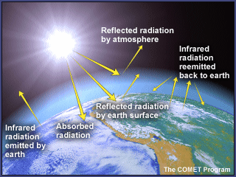
Site Used:
"UCAR - University Corporation for Atmospheric Research." UCAR. N.p., n.d. Web. 26 Apr. 2014.
What are greenhouse gases and what about their structure makes them greenhouse gases?
The greenhouse gases are designed to absorb heat. The greenhouse gases are methane, carbon dioxide, water vapor and nitrous oxide. Carbon dioxide consists of two oxygen atoms, and one hydrogen atom. Carbon dioxide is mostly produced by fossil fuels, and in 2004, it accounted for 74% of the greenhouse gases emitted. There are few ways to remove carbon dioxide from the atmosphere, such as reforestation and the use of improved soils. In a carbon dioxide molecule the atoms are bonded together tightly, because all three atoms want a full valence electron shell. When the carbon dioxide molecule absorbs infrared radiation, it vibrates. The molecule then emits the infrared radiation back into the air, and will most likely be absorbed and emitted by another greenhouse gas molecule. This cycle helps keep the atmosphere warm. Methane counts for 14% of the greenhouse gases. Methane is produced by waste management, agricultural activities, and a number of natural sources. Nitrous oxide accounts for 8% of the greenhouse gases, and is mostly produced by fertilizer use. Other molecules that are in the air, such as N2 and O2, cannot absorb heat because they are bound together so tightly. Because they cannot absorb heat, they do not cause to the greenhouse effect.
Site Used:
"US Environmental Protection Agency." EPA. Environment
How has the amount of greenhouse gases in the atmosphere changed over time?
As shown in the two graphs below, as the world population has increased, each of the greenhouse gases has increased as well. This is due to the cutting down of forests, burning fossil fuels, and the production of natural gases. EPA suggests the factors that have increased the amount of carbon dioxide emitted so significantly are “population growth, economic growth, changing energy prices, new technologies, changing behavior, and seasonal temperatures.” Since the year 1990, greenhouse gases have increased by five percent. As shown in the second table, carbon dioxide is the most prevalent and quickly produced greenhouse gas.

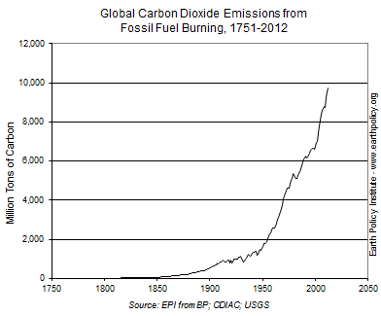

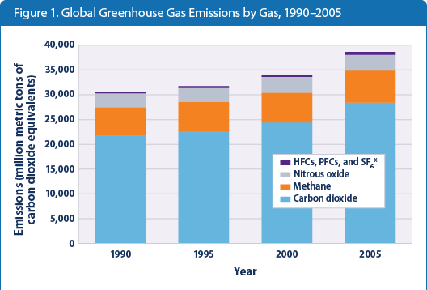

Sites Used:
Columbia University | Earth and Environmental Sciences." Columbia University | Earth and Environmental Sciences. N.p., n.d. Web. 29 Apr. 2014

"US Environmental Protection Agency." EPA. Environmental Protection Agency, n.d. Web. 24 Apr. 2014.

What are some predictions of global climate change?
The increase of greenhouse gases in our atmosphere could have many effects on global climate change. An increase in Earth’s average temperature will lead to glaciers and ice melting, resulting in an increase of sea level. These changes could have a big effect on many factors of life that we rely on such as food production, human and animal health, changes in the ecosystem and fresh water supplies.
The water and sea life of the oceans are also being affected by climate change, which is called ocean acidification. When the ocean absorbs carbon dioxide, it turns to carbonic acid, which increases the acidity. Although ocean acidification is slowing down climate change because less carbon dioxide is in the air, the ocean life is being affected. This mostly affects the surface of the ocean. According to national geographic, the acidity in the ocean has increased by 25% in the past two centuries.
The environmental defense fund suggests, “The Earth could warm another 2 to 11.5°F this century if we fail to reduce emissions from burning fossil fuels and deforestation—devastating our livelihoods and the natural world we cherish.” Along with an increase in temperatures, comes threatening weather. The years 2000-2009 were the hottest record recorded decade, leading to many downfalls in climate change. The world is facing an increase in droughts, forest fires, terrifying hurricanes and an increase in flooding. This prediction has the ability to be devastating if the problem of global warming does not quickly decrease. If the amount of carbon dioxide in the atmosphere continues to increase like it has in the past, our planet will face many problems in all different areas of life.

Sites Used:
"Environmental Defense Fund." Environmental Defense Fund. N.p., n.d. Web. 29 Apr. 2014.

"The Ocean -- National Geographic." National Geographic. N.p., n.d. Web. 29 Apr. 2014.
How do the emissions from energy production by nuclear power plants compare to that of coal and of natural gas?
Nuclear power plants, coal, and natural gas all produce emissions, some better than others. A coal plant produces mercury, nitrogen oxides, carbon dioxide, and sulfur dioxide, compounds. Fortunately, they are required to have equipment that lower the amount of gas that they release into the air. On the negative side, other processes involved in coal plants produce excess emissions. This includes transportation, mining the coal, and cleaning. A natural gas power plant produces carbon dioxide, and nitrous oxide, both of which are natural gases. Methane can also be released if not all of the natural gas is burned off or a leak occurs. On the other hand, a nuclear power plant does not emit any emissions, but it does emit small amounts of radiation. However, fossil fuel is emitted during the uranium mining process and the transportation of the uranium.
"US Environmental Protection Agency." EPA. Environmental Protection Agency, n.d. Web. 24 Apr. 2014.

How is the combustion of fossil fuels related to global climate change?
When fossil fuels are burned, methane and oxygen react. The reaction produces water vapor and carbon dioxide. The reaction that takes place looks as follows:
CH₄ + 2 O₂ > CO₂ + 2 H₂O + energy
The problem with burning fossil fuels is that they produce large amounts of carbon dioxide, which makes earth hold more heat in the atmosphere. The more carbon dioxide that is in the atmosphere, the faster the climate is changing.

Sites Used:
"What's New." American Nuclear Society. N.p., n.d. Web. 26 Apr. 2014

"Elmhurst College: Elmhurst, Illinois." Elmhurst College: Elmhurst, Illinois. N.p., n.d. Web. 29 Apr. 2014.

What safety features are being built into future light water reactors?
Past accidents have had a big impact on improving light water reactors. The goal is to make the plants more efficient, economical, and reduce the risk of an accident. According to http://www.energy.gov, The Light Water Reactor Sustainability Program is working on “developing the scientific basis to extend existing nuclear power plant operating life beyond the current 60-year licensing period and ensure long-term reliability, productivity, safety, and security.” Right now, third generation reactors are being developed. The World Nuclear Association states that the third generation reactors will have the following:
- a standardized design for each type to expedite licensing, reduce capital cost and reduce construction time,
- a simpler and more rugged design, making them easier to operate and less vulnerable to operational upsets,
- higher availability and longer operating life – typically 60 years
- further reduced possibility of core melt accidents
- substantial grace period, so that following shutdown the plant requires no active intervention for (typically) 72 hours,
- resistance to serious damage that would allow radiological release from an aircraft impact,
- higher burn-up to use fuel more fully and efficiently and reduce the amount of waste
- greater use of burnable absorbers ("poisons") to extend fuel life
As for safety features, fission products are used to cool down the plant. When the plant shuts down, the fission products are still radioactive, so many steps have been taken to ensure that they are safely disposed of. In order to control the amount a radiation that a plant produces, many layers are built around the reactor to block the radiation. Also protected by security guards, nuclear power plants have many safety features.
Sites Used:
"WNA in Japanese:." World Nuclear Association. N.p., n.d. Web. 29 Apr. 2014

"Energy.gov." Department of Energy. N.p., n.d. Web. 29 Apr. 2014.
"Welcome to the OECD Nuclear Energy Agency." Nuclear Energy Agency. N.p., n.d. Web. 29 Apr. 2014.

What are potential risks to nuclear power plants from events like natural disasters and terrorist attacks?
A terrorist attack or sabotage at a nuclear power plant is a constant worry for power plants around the globe. There is a possibility that supplies from a power plant could be stolen to create a nuclear bomb.
In order for the reactor to be hit in a nuclear power plant, a plane would have to go through thick concrete, and then hit the reactor. Although there is a small chance this could happen, it is very unlikely.
Natural disasters also pose a danger to the safety of a nuclear power plant. If a natural disaster were to damage the vessel or the equipment that control the uranium, the amount of heat being produced could not be controlled. This would lead to a nuclear meltdown. Fukushima is a great example of a natural disaster resulting in a nuclear disaster. This disaster was caused by an extremely powerful tsunami following an earthquake. Terrorist attack and natural disasters both pose threats to nuclear power plants. The scary part is, we have seen them right before our eyes.
Site Used:
"Donate." Top Stories RSS. N.p., n.d. Web. 29 Apr. 2014

Nuclear Waste
Nuclear waste is the product of radioactive material after it’s life has come to an end or any substance that has come into contact with and been contaminated by nuclear material. All of the radioactive material that is used and stored inside of the containment structures eventually has to be exchanged and then turns into waste. The uranium fuel that powers the nuclear reactor is a high-level radioactive waste. The neutrons in the uranium split and are absorbed by the fuel, forming plutonium, a radioactive element with a long life, this is what is harmful to the atmosphere and the environment.
"NDA Attacked over Magnox Contract." Radioactive Waste Management. N.p., n.d. Web. 30 Apr. 2014.
"What Are Nuclear Wastes and How Are They Managed?" What Are Nuclear Wastes? N.p., n.d. Web. 30 Apr. 2014.

The Environmental and Safety Considerations for the Storage of Nuclear Waste
The storage of nuclear waste is a complicated process. There are three levels of intensity by which radioactive waste is categorized: low-level, intermediate-level and high-level waste. When radioactive waste is marked as “low-level waste” it means that it is not considered harmful to people of the surrounding environment. It mainly comes from materials such as concrete, clothing or metals. Low-level waste is either stored on site at the nuclear power plant or shipped to a low-level waste disposal site (IAEA, Focus). The disposal sites are a good option for large amounts of radioactive waste because they contain the material in safer areas. Most disposal sites in the U.S. can be found in one of the following states: South Carolina, Washington, Utah and Texas (IAEA, Storage).
Intermediate-level waste, also known as ILW, is comprised of resins, chemical sludge, metal fuel cladding and contaminated materials from a plant reactor. This particular level of waste is stored in the same manner as the low-level waste, but it requires shielding in steel containers due to the higher level of radiation (IAEA, Focus). In order to protect the environment by not letting the waste into unspecified areas, the packages used to transport the nuclear waste are designed to withstand the various conditions that it may be exposed to in transport (World, Transport).
Finally, high-level waste has the most potential to cause harm because it contains fission products and transuranic elements that are generated in the reactor core. Over 95% of the total waste produced for electricity generation is highly radioactive (Representing, 2013). HLW is stored on site for multiple years in large tanks of water to cool the waste until it reaches a point that it can be vitrified and placed into borosilicate glass. Vitrification is a process used to stabilize and encapsulate HLW that involves mixing the waste with a substance that will crystallize and calcinate when heated. The process of calcination removes the water from the waste to enhance the stability of the resulting glass product (Thompson, 2010). The melted radioactive waste is subsequently encapsulated into heavy stainless steel cylinders after vitrification and stored in disposal repositories. Often times, HLW will create short-lived fission products. These products are derived from long-lived actinides and the distinction between the long and short-lived product is essential in the management and disposal of HLW (Representing, 2013).
If the necessary steps are not taken to ensure safe storage of the radioactive waste, it can have serious health effects on humans. For instance, when the human body is exposed to plutonium, it will often lead to detrimental effects on internal body systems. Exposure to plutonium can occur during ingestion, inhalation, and contamination to an open wound. The least likely type of exposure is inhalation, yet it causes the most severe effects. It is difficult to create an airborne dispersion of such a heavy metal, but when it does occur it is generally through insoluble plutonium oxide having a particle size less than 0.01 mm. When this chemical is inhaled, the majority of it is expelled through exhalation or mucous flow from the bronchial system. Then the small amount that is not expelled gets transferred to the blood or lymph system and progressively works its way towards the liver and bones (World, Plutonium). There is evidence that when plutonium is inhaled it can cause cancer, mutations, and various other terminal illnesses.
The design of the disposal repository is an essential aspect of storing nuclear waste because even a miniscule mistake could contaminate groundwater with radioactive elements, affecting humans and wildlife. The vaults containing the radioactive waste are similar to a swimming pool, reinforced by several inches of concrete and stainless steel in order to prevent any possible draining. The nuclear waste itself is placed in racks under approximately twenty feet of water. The threat of radiation is eliminated because both the water and the stainless steel causes the radiation to rebound, therefore keeping it in the pool.
As long as nuclear power companies take the precautions needed to store their waste in the appropriate manner, the potentially dangerous implications of radioactive elements can be minimized.

Works Cited:
"Disposal Aspects of Low and Intermediate Level Decommissioning Waste."Pub.iaea. International Atomic Energy Agency, n.d. Web. 19 Apr. 14.

"Focus on Low and Intermediate Level Waste." IAEA.org. International Atomic Energy Agency, n.d. Web.

"Plutonium." Plutonium. World Nuclear Association, n.d. Web. 24 Apr. 2014.

“Radioactive Waste Management" Representing the People and Organizations of the Global Nuclear Profession. World Nuclear Association, Nov. 2013. Web. 27 Apr. 2014.

"Storage of Radioactive Waste." Safety Standards for Protecting the People and the Environment. International Atomic Energy Agency, n.d. Web.

"Transport of Radioactive Materials." Transport of Radioactive Materials. World Nuclear Association, n.d. Web. 24 Apr. 2014.

"What Is Uranium? How Does It Work?" What Is Uranium? How Does It Work. World Nuclear Association, n.d. Web. 25 Apr. 2014

Thompson, Linda. "Vitrification of Nuclear Waste." Vitrification of Nuclear Waste. Stanford University, 28 Nov. 2010. Web. 29 Apr. 2014..

Emissions from Nuclear Power Plants
Emissions from nuclear power plants are the gases and radiation released from the power plant. Nuclear power plants do not directly release greenhouse gases from the creation of nuclear energy; the emissions come from outside sources. These sources include: emissions from the construction of the plant, mining and processing of fuel used in the plant, disposal of fuel other waste from running the plant, and decommissioning.
According to the Nuclear Energy Institute and World Nuclear Association, if the emissions of a nuclear power plant were compared to other forms of energy production, it would be close to that of wind and hydro power; far less than that of coal or natural gas power plants.
Nuclear power plants to not emit carbon dioxide gas, sulfur dioxide, or nitrogen gas. However, emissions are seen from the burning of fossil fuels in the uranium enrichment process, and from the transportation of uranium to the power plant. Because nuclear power plants do not release harmful chemicals into the air, the damage to the air is significantly less than that of coal or natural gas energy power plants (Air 2014).

"UCAR - University Corporation for Atmospheric Research." UCAR. N.p., n.d. Web. 26 Apr. 2014.
The Best Financial Estimates of the Cost of Nuclear Power Generated Electricity
The Capital Cost of building a power plant is the amount of money it takes to build the power plant. This includes building materials, labor, etc. This price varies depending on the year the plant is built, and the organization giving the statistic. These are the prices of building a power plant based on different sources:
- The Nuclear Energy Agency (NEA): US$ 3,850/kW
- The US Energy Information Administration (EIA): US$ 5,339/kW.
- The French national audit body; the Cour des comptes: € 3,700/kW (~US $5,119)
- China: Less than $2000/kW (the lower cost is estimated to be in part because of lower labor costs)

The Operating Cost of a nuclear power plant is the cost it takes to run the power plant and create the energy produced from it. This cost includes electricity, water, labor, etc. The average cost in 2012 according to the Nuclear energy institute, is 1.65 cents/kWh (Costs 2014).
The External Costs of a nuclear power plant are the disaster cleanup costs were a spill or other disaster to take place. Each state processing nuclear power must make payments to the Nuclear Waste Fund, a fund used to clean spills of nuclear waste from power plants. There is approximately $35.8 billion (1/10th cent kWh generated at a power plant), out of this, $10.8 billion has been spent (Nuclear 2014). For more information on individual state payments to the Nuclear Waste Fund, visit this link: http://www.nei.org/Knowledge-Center/Nuclear-Statistics/Costs-Fuel,-Operation,-Waste-Disposal-Life-Cycle/Nuclear-Waste-Fund-Payment-Information-by-State
The final cost of a nuclear power plant is the interest needed to pay from loans taken out to build the plant originally. Unless the money for building the plant is already attained, there will be a large amount of interest to pay back for a number of years.
Nuclear power is used for 13% of the world’s power annually, and makes between $450 and $470 million each year (Nuclear 2014). Power plants give both state and federal taxes, state taxes are approximately $16 million each year, and approximately $67 million are paid in federal taxes each year (Air 2014)
The table below shows the approximate cost to make 1kg of Uranium. The Uranium starts out as Triuranium Octoxide (U3O8), costing approximately $130 per 1 kg to harvest. The Uranium then undergoes a chemical process where the O8 is taken out; making pure Uranium-235 and Uranium-238, the cost of this is approximately $11 per 1 kg, and $83 in the table below. The Uranium is then enriched, a process where the Uranium-235 is separated from the Uranium-238. Uranium-238 is then discarded and the Uranium-235 is left as a pure form. The cost of this is approximately $120 per 1 kg, and $880 in the table below. The Uranium-235 in pure form is then turned into a fuel pellet to be used as energy, costing approximately $240 per 1 kg. Each fuel pellet is approximately 7 grams. The price of a fuel pellet (form of energy made by nuclear power plants), is estimated to be approximately $16.50 (see table below) for one 7 gram fuel pellet (Air 2014)
Approximate cost to make 1kg of Uranium (2013)
Uranium: | 8.9 kg U3O8 x $130 | US$ 1160
Conversion: | 7.5 kg U x $11 | US$ 83
Enrichment: | 7.3 SWU x $120 | US$ 880
Fuel fabrication: | Per kg. | US$ 240
Total, approx: |  | US$ 2360

The decommissioning of a nuclear power plant includes everything needed to stop production of nuclear energy at that site. This includes taking down buildings, and restoring the site to its original state. The estimated cost of this is between $300- $500 million, with approximately $100 million going towards used fuel, and approximately $300 million towards site restoration (NDA 2014).
Bibliography:
http://www.epa.gov/cleanenergy/energy-and-you/affect/air-emissions.html:
"Air Emissions." EPA. Environmental Protection Agency, n.d. Web. 29 Apr. 2014.

http://www.world-nuclear.org/info/Economic-Aspects/Economics-of-Nuclear-Power/: "The Economics of Nuclear Power." Nuclear Power Economics. N.p., n.d. Web. 27 Apr. 2014.

http://www.nei.org/Knowledge-Center/Nuclear-Statistics/Costs-Fuel,-Operation,-Waste-Disposal-Life-Cycle:
"Costs: Fuel, Operation, Waste Disposal & Life Cycle." Nuclear Energy Institute -. N.p., n.d. Web. 28 Apr. 2014.

http://www.nei.org/Master-Document-Folder/Backgrounders/Fact-Sheets/Nuclear-Power-Plants-Contribute-Significantly-to-S:
"Fact Sheets." Nuclear Energy Institute. N.p., n.d. Web. 27 Apr. 2014.

http://www.world-nuclear.org/info/nuclear-fuel-cycle/power-reactors/nuclear-power-reactors/:
"Nuclear Power Reactors." Nuclear Reactors. N.p., n.d. Web. 27 Apr. 2014.

http://epsc221.wustl.edu/Lectures/221L36.pdf/ Chemistry in Context:
Eubanks, Lucy T. Chemistry in Context: Applying Chemistry to Society. Boston: McGraw-Hill Higher Education, 2006. Print.

http://www.nei.org/Knowledge-Center/Nuclear-Statistics/Costs-Fuel,-Operation,-Waste-Disposal-Life-Cycle/Nuclear-Waste-Fund-Payment-Information-by-State:"Nuclear Waste Fund Payment Information by State." Nuclear Energy Institute. N.p., n.d. Web. 30 Apr. 2014.
http://www.world-nuclear.org/info/nuclear-fuel-cycle/nuclear-wastes/decommissioning-nuclear-facilities/:
"NDA Attacked over Magnox Contract." Nuclear Decommissioning: Decommission Nuclear Facilities. N.p., n.d. Web. 30 Apr. 2014.

The Greenhouse Effect and Its Relation to Global Climate Change
Without the greenhouse effect, temperatures on Earth would not be livable. When the sun’s radiation reaches our atmosphere, some is redirected back into space, while some reach through and heat up the surface of the Earth. The heat from the Earth’s surface is then radiated outward and caught in the greenhouse gases contained in our atmosphere. This keeps heat from escaping into space. While this is vital to our survival and life as a whole, it is also why the Earth is heating up so rapidly. The burning of fossil fuels and other activities intensifies the warming effect by releasing additional greenhouse gases into the atmosphere (such as carbon dioxide and methane). Greenhouse gases come from various sources and all have different heat trapping capabilities.
Greenhouse Gases and Their Structure
Greenhouses gases are gases that trap heat in the atmosphere. The greenhouse gases found in our atmosphere are carbon dioxide, methane, nitrous oxide, and fluorinated gases. Despite being a relatively low greenhouse gas, so much CO₂ has been emitted since pre-industrial times that it has had the largest impact on the enhanced greenhouse effect. In 2012 it accounted for 82% of all greenhouse emissions! It is produced primarily by fossil fuels that are burned through the use of vehicles, power plants, and industry, and emissions continue to increase every year. Methane only makes up less than two of every million molecules in the air and stays in our atmosphere for only ten years. Despite this, methane traps 20 to 25 times as much energy in that decade as carbon dioxide does in a century. Nitrous oxide accounts for only about 300 in every billion molecules in the air, but is 300 times more powerful than CO₂ at enhancing the greenhouse effect and stays in our atmosphere for around 100 years. Carbon dioxide (CO₂), water vapor (H₂O), methane (CH₄, nitrous oxide (N₂O) are all molecules composed of more than two loosely bound component atoms. These molecules can absorb radiation because they are able to vibrate with the absorption of heat. The two main components of the atmosphere (N₂ and O₂) are too tightly bound to vibrate and as a result do not absorb heat. When they absorb radiation, they begin to vibrate. Eventually, it will re-emit the radiation that it absorbed. That radiation will most likely be absorbed by another greenhouse gas in the atmosphere. The absorption-emission-absorption cycle effectively keeps the atmosphere warm.

"Global Warming Interactive, Global Warming Simulation, Climate Change Simulation - National Geographic." National Geographic. N.p., n.d. Web. 29 Apr. 2014.

The Change in The Amount of Greenhouse Gas in The Atmosphere Over Time
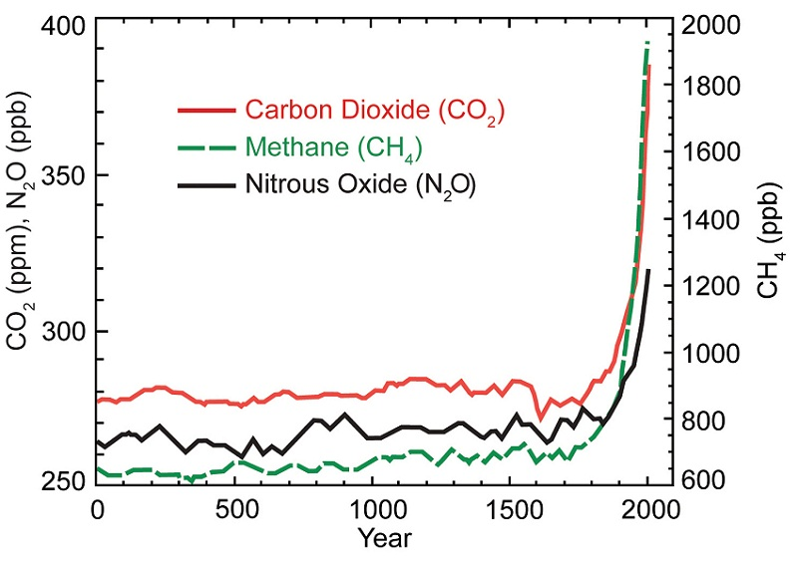
The levels of Greenhouse gases have risen majorly since the early 1900’s, as the graph shows there was a consistent level of greenhouse gases (carbon dioxide, methane, and nitrous oxide). Before the last century the greenhouse gas levels in the environment stayed consistently at about 700 ppb for methane, 265 ppb nitrous oxide, and 280 ppm carbon dioxide. since 1900 however the levels have spiked to 320 ppb nitrous oxide, 1950 ppb methane, and 380 ppm carbon dioxide. This is most likely due to the industrial revolution. During the industrial revolution many western countries burned fossil fuels (coal, petroleum, and natural gas) which caused the large spike in carbon emissions through combustion reactions.

Predictions of Global Climate Change
Because of the continuing international reliance on fossil fuels that emit greenhouse gases and the developing technology of third world countries the shown upward trend that began in the early 20th century will most likely continue for some time. Then, as renewable energy resources are developed or until the non-renewable resources are mostly used up. The levels will most likely normalize to close to their original positions, though very gradually much more gradually than the initial spike.
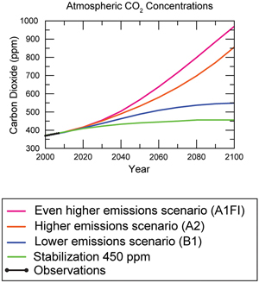
This graph from the EPA shows 4 hypothetical trends in greenhouse gases until the year 2100. The first, from top to bottom, suggests that our greenhouse gas levels will increase at an even faster rate than previously observed, this means that the world would consume more fossil fuel powered energy, possibly by the spread of energy consumption to countries like India. The second shows a mostly linear progression from our current sampled trend, this would happen if we continued consumption at the rate that we have for the last few decades. The third shows a hypothetical in which the rate of emissions would lower from our contemporary model, this would happen if we weaned ourselves off fossil fuels and onto other fuel sources. The fourth shows the stabilization in which no more emissions are produced, leading to level stabilization, to attain this trend we would need to end or mostly end fossil fuel consumption and turn to more green methods such as hydroelectric and wind energy. The two that lower the greenhouse gas emissions would, theoretically, prevent greenhouse gases from causing the world’s temperature to increase beyond the two degree celsius threshold that marks the impossibility of stabilization to the original levels. The potential issues of climate change include melting polar ice caps which would lead to higher global sea levels. Also the increase in temperature could lead to more extreme weather events, which we have seen a precursor to in recent years. The higher global temperature would lead to possible extinctions of animals who could not adapt to the changing heat.
Emissions from Nuclear Power Plants Compared to Coal and Natural Gas Plants
Greenhouse gas emissions from nuclear plants are typically lower than the emissions from any other type of energy production except hydroelectric and wind, the range of studies also suggested that biomass is sometimes lower than nuclear. Nuclear energy is typically producing 2 metric tons of carbon dioxide per every gigawatt hour, compared to coal which normally produces 900 metric tons of carbon dioxide per every gigawatt hour, and 750 metric tons per every gigawatt hour for petroleum.
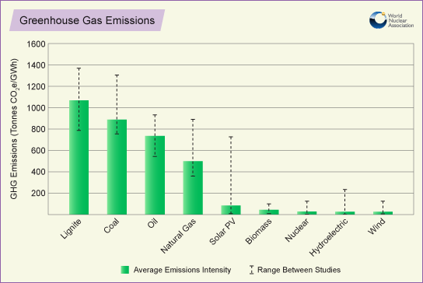

Combustion of Fossil Fuels Related to Global Climate Change
The combustion of fossil fuels is directly related to global climate change. Fossil fuels are burned to create heat, through a combustion reaction. In a combustion reaction the hydrocarbon molecules of the fuel and oxygen molecules react to each other creating water (H2O), carbon dioxide (CO2), heat, and light.The heat created in the reaction is used to heat water into steam which then turns a turbine, the co-products from the reaction, the water vapor and carbon dioxide, are released into the the atmosphere. Due to a process called the greenhouse effect molecules such as carbon dioxide trap heat from that warms the earth. By increasing the amount of carbon dioxide in the atmosphere the atmosphere is trapping more heat from the sun increasing the world’s temperature.

Levelized Costs of Electric per kWh (Kilowatt Hour)
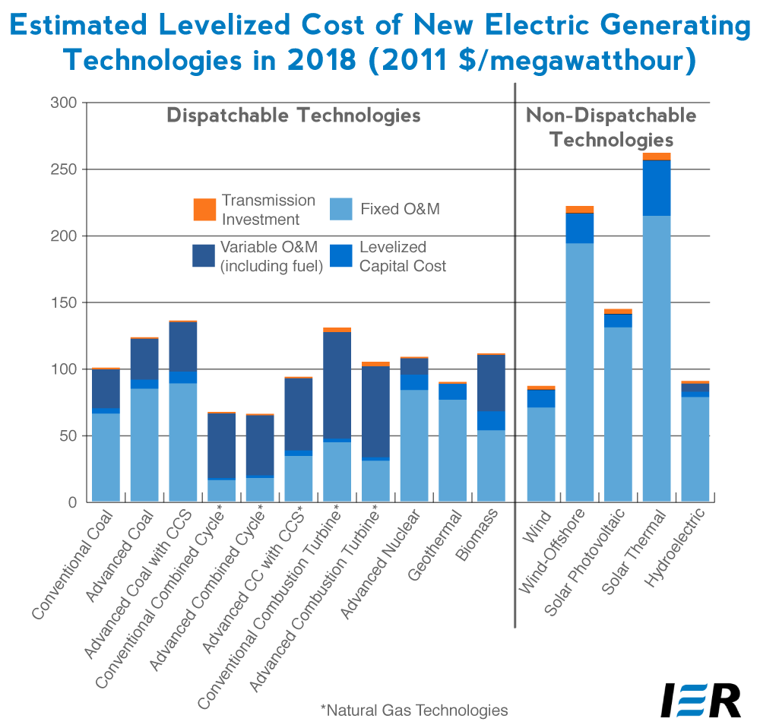
A levelized cost for energy is the cost of energy for the average consumer. The amount of energy is measured in megawatt hours, which stands for the amount of energy in watts used in an hour. Normally the cost for the average consumer is around 9.7 cents per kilowatt hour, however this value is largely inflated by the electric company. The production cost for natural gas in normally around 5 cents, for nuclear it is around 3 cents. The levelized cost for advanced nuclear technology is higher in its rate than the other types of energy, including coal, biomass and hydroelectric.
Works Cited
"Future Climate Change." EPA. Environmental Protection Agency, 3 Apr. 2014. Web. 25 Apr. 2014.

"Greenhouse Gas Emissions Avoided through Use of Nuclear Energy." Greenhouse Gas Emissions Avoided through Use of Nuclear Generation. World Nuclear Association, n.d. Web. 27 Apr. 2014.

Kruitbosch, Scott. "The Weather Channel and Climate Change Ignorance." The Roger Tory Peterson Institute of Natural History RSS. The Weather Channel, n.d. Web. 23 Apr. 2014.

"Levelized Costs of New Electricity Generating Technologies." Institute for Energy Research. Institute for Energy Research, 2013. Web. 27 Apr. 2014.

